This documentation is the step by step explanation for implementing SendOneOnOneChatMessage in IR page in eManager.  
  
The folder will contain 3 main files which should be changed/added for functioning of the cod:  
1. SendOneOnOneChatMessage.java   
2.Communication.java (“D:\Projects\eManagerWeb\src\main\java\communication\Communication.java)”  
3.irBasicInfo (“D:\Projects\eManagerWeb\src\main\webapp\comm\irBasicInfo.jsp”)  
  
All changed files:  
  
To add 1. File in path: “ D:\Projects\eManagerWeb\src\main\java\communication”  
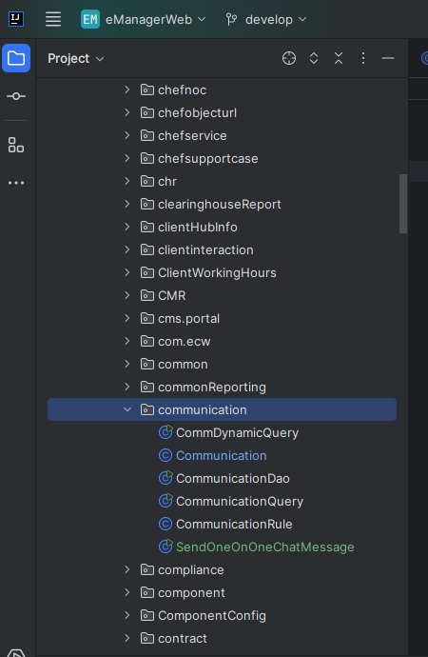

In the same file we can find Commnication.java, changes needed:  
  
@POST  
@Path("msg")  
public void sendTeamsMessage(@FormParam("data") String data) {  
 try {  
 JSONObject obj = Utils.*decodeBase64toJSONObject*(data);  
 int loginId = Utils.*getParamIntS*(httpRequest.getSession().getAttribute("uid").toString(), 0);  
 String irid = obj.optString("irid");  
 String userIds = obj.optString("userIds");  
 String notesTeams = obj.optString("notesTeams");  
 String[] userIdsArr = userIds.split(",");  
 GeneralController gc = new GeneralController();  
  
 JSONObject irData = SendOneOnOneChatMessage.*getEmailByIrid*(irid);  
 String email = irData.optString("email");  
 irData.put("notesTeams", notesTeams);  
 irData.put("noteByName", gc.getUserName(loginId));  
 String userId = SendOneOnOneChatMessage.*getUserId*(email);  
 SendOneOnOneChatMessage.*sendMessageToUser*(userId, irData);  
 for (String userId2 : userIdsArr) {  
 int userInt = Utils.*getParamInt*(userId2, 0);  
 //userIdList.add(gc.getUserEmail(Utils.getParamInt(userId,0)));  
 if(userInt > 0) {  
 String userId1 = SendOneOnOneChatMessage.*getUserId*(gc.getUserEmail(userInt));  
 SendOneOnOneChatMessage.*sendMessageToUser*(userId1, irData);  
 }  
  
 }  
 } catch (Exception e) {  
 *logger*.error(e.getMessage(), e);  
 }  
}

Now to add button in the IR page changes should be done in irBasicInfo.jsp:  
  
Add the highlighted code.

Next add “sendMsgTeams” method in the same code:  
commBasicInfo.setFileDropZone = function(){  
   
 Dropzone.options.myAwesomeDropzone = {  
 paramName: "file",  
 dictDefaultMessage: "",   
// acceptedFiles: "image/*,application/pdf,.txt,.csv",  
 maxFilesize: 10, // MB  
 timeout: 420000, // 7 min  
 addRemoveLinks : true,  
 uploadMultiple: true,  
 parallelUploads: 10,  
 maxFiles: 10,  
 clickable : "#uploadIcon",   
 previewsContainer: '#dropzonePreview',  
 accept: function(file, done) {  
 if((file.size / 1024) <= 5120){  
 done();  
 }else{  
 done("You can not upload file that are larger than 5MB.");  
 emgrToast.warn("Please upload file size more than 5MB by one drive and share its link.");  
 return false;  
 }  
 },  
 init: function() {  
 commBasicInfo.$prefix.find('#my-awesome-dropzone .dz-default').removeClass('dz-message');  
   
 commBasicInfo.$prefix.find("#saveBtn").on("click",function(){  
 commBasicInfo.saveNote();  
 })  
 commBasicInfo.$prefix.find("#sendMsgTeams").on("click",function(){  
  
 var html = '<div class="form-group input-group" style="margin: 1px 0 0 0;">'+  
 '<h5>To:</h5>'+  
 '<input type="text" class="form-control input-sm" id="teamsUser" placeholder="Select users" autocomplete="off">'+  
  
 '<h5>Note:</h5>'+  
 '<textarea type="text" class="form-control input-sm" id="teamsNotes">'+  
 '</textarea>'+  
 '<span class="input-group-btn" id="" >'+  
 '<button class="btn btn-default btn-sm" type="button" onclick="$(this).parent().parent().find(\'input\').val(\'\')" style="height: 30px;align-items: center; display: flex;">'+  
 '<i class="fa fa-minus"></i>'+  
 '</button>'+  
 '</span>'+  
 '</div>';  
 var Container = ".ir_teams_popup";  
 BootstrapDialog.show({  
 title: 'Send IR Notification To',  
 message: html,  
 draggable: true,  
 closable: true,  
 closeByBackdrop: false,  
 closeByKeyboard: false,  
 cssClass: 'ir_teams_popup',  
 buttons: [{  
 label: 'Cancel',  
 cssClass: 'btn-default btn-sm',  
 action: function (dialog) {  
 dialog.close();  
 }  
 }, {  
 label: 'Proceed',  
 cssClass: 'btn-primary btn-sm',  
 action: function (dialog) {  
 var userIds = $.trim($(Container + " #teamsUser").val()).length > 0 ? $(Container + " #teamsUser").val() : "";  
 var notesTeams = $.trim($(Container + " #teamsNotes").val());  
  
 commBasicInfo.sendMessage(userIds,notesTeams);  
 dialog.close();  
 }  
 }],  
 onshown: function (dialog) {  
  
 var ecwUserUrl =Home.restUrl + "General/getEcwUsersFortokenInput?limit=10";  
 $(Container + " #teamsUser").tokenInput(ecwUserUrl, {  
 theme: "facebook",  
 preventDuplicates: true  
 });  
 }  
 });  
  
 })  
  
Then,

If the above documentation didn’t help, then I am putting the code files in the folder, can refer them.